Information on Plays
Country: Srilanka & Rwanda
Group Name: Stages Theatre Group & Mashirika
Play Name: Dear Children Sincerely
Director – Ruwanthie De Chickera &
Scriptwriter – Ruwanthie De Chickera
Introduction to Play: Dear Children, Sincerely… is a play that was devised by Sri Lankan and Rwandan artists through interviews conducted with elders of both the countries born in the 1930’s.Part of a wider ongoing theatre project initiated by Stages Theatre Group, the first performance and international collaboration took place in Kigali, Rwanda at the Ubumuntu Arts Festival held in commemoration of the Rwandan Genocide. Three stories were created for this play, which examine key events in the two countries.
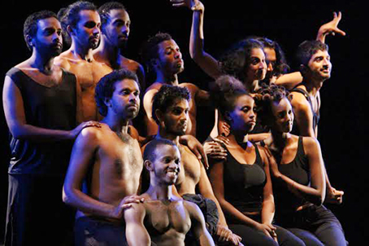

Country: Armenia
Group Name: Theatre for Changes
Play Name: At a Dead End in the Open Sea
Director – Hayk Sekoyan
Scriptwriter – Hayk Sekoyan
Introduction to Play: Aimed at peaceful conflict resolution and friendship building across borders, the forum theatre play “At a Dead-End in the Open Sea” tells a story of two young men – Armenian and Turkish, who have appeared on a small boat after a
Ship wreck in the middle of nowhere in the sea. Both of them have negative prejudices towards each other, but still they ought to find a common language and a way out in order to survive. While searching for solutions, they constantly argue about the right sailing direction, which will take them back to the shore. Unable to negotiate with each other, they establish a conditional border on the boat. However, this does not stop their disputes and as a result of their endless arguments, they finally reach to a mutual agreement that is to cut the boat and be free and independent from each other. This final decision, however, becomes the reason of their tragic death.

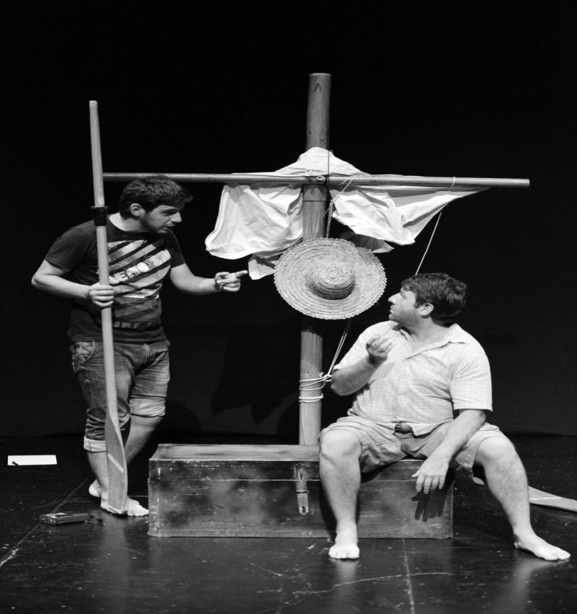

Country: Mozambique
Group Name: Grupo de Teatro Girassol
Play Name: Nkatikuloni ( A OUTRA)
Director – Joaquim Sebastião Matavel
Scriptwriter – Joaquim Sebastião Matavel
Introduction to Play: The performance is a reflection on the condition of being a wife and be another wife of the same husband, in a globalized society in which the values ​​and habits associated to the African people culture are in the crossroads of recognition or legitimacy under point of view of western concepts.

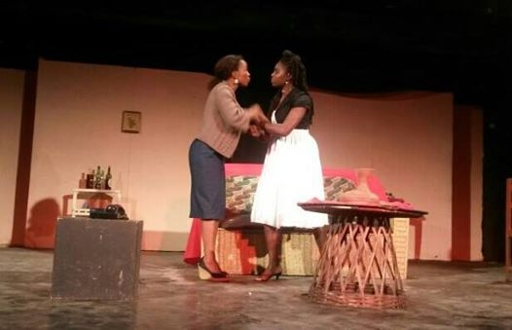

Country: Central African Republic
Group Name: LES PERROQUETS
Play Name: Les Anciens Combattants ( Veteran Fighters )
Director – Simphor Gervais Kpignon
Scriptwriter – Simphor Gervais Kpignon
Introduction to Play: One day, a veteran who lives in his native village decides to visit his daughter married to a customs officer in the capital. Arriving at the customs checkpoint, all his luggage was seized by customs. This requires him clearance of all packages (peanut legs, bag of cassava, goats etc ...). In the discussion, he realizes that Customs is the husband of his daughter. So he decides to have not gone to this "thief", husband of his daughter. He will live with his old friend, a veteran. Their meeting turns into adventure on Africa, it is said is "wrong go way".

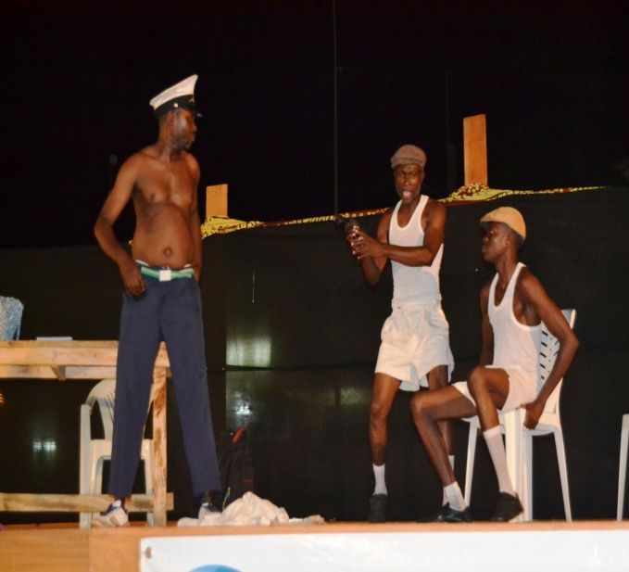

Country: India
Group Name: Mandala (the magic circle)
Play Name: AKKARMASHI
Director – Lokesh Jain
Scriptwriter – Lokesh Jain
Introduction to Play: The play is based on autobiography of Shri Sharankumar Limbale, the Dalit writer from Mahahrashtra. It is a first-person account of the struggle against poverty, deprivation, discrimination and violence. It captures the dehumanizing impact of caste oppression in Hindu society. The Sola Performance is story telling based where the actor as Sharan Kumar Limbale recounts his past experiences as a Dalit. Akarmashi is a touching story of an illegitimate child born out of an unconventional and socially immoral relationship between a man and a woman.

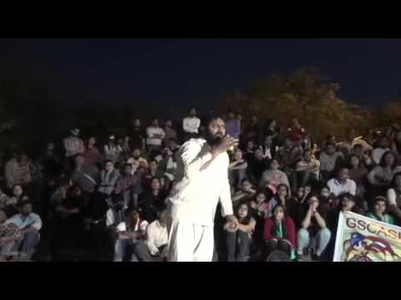

Country: India
Group Name: Asmita Theatre Group
Play Name: A Woman Alone
Director – Arvind Gaur
Scriptwriter – Arvind Gaur
Introduction to Play: 'A Woman Alone' is the story of a housewife driven to extreme measures by an abusive husband, a younger lover, a perverted brother-in-law, a peeping neighbor and a crying baby.The entire story is told by the woman herself, while chatting to her neighbor whom she had just met through the window. Anger, frustration, hope, regret, guilt and determination are just some of the inner turmoil this woman goes through. The perverted brother-in-law who doesn't let his wheelchair bound disabled body stop him from interfering with any woman in sight, triggers off laughter, reminding the audience that they're watching a comedy play after all! But things soon become darker as she takes extreme measures to save her sanity. This play was written by acclaimed Italian playwrights Dario Fo and Franca Rame, two of Italy's best-known performers and political activists. A one-woman show, 'A Woman Alone' is a testimony to the human spirit and hits on stereotypes, violence and demonstrates that which people are all capable of doing when pushed to the limit of their patience.
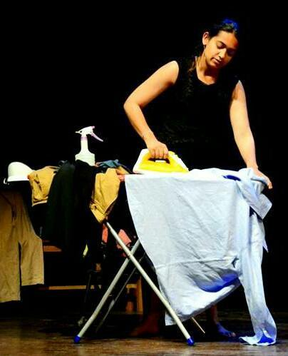

Country: Nepal
Group Name: Mandala Theatre-Nepal
Play Name: Boksiko Ghar (roughly translated HOUSE OF WITCH)
Director – Sulakshyan Bharati
Scriptwriter – Sulakshyan Bharati

Introduction to Play: This play is a journey of a nine year old girl. She gets married at the age of nine. All she tries is to live her life with the boundaries given by the society. Eventually her husband died in an accident, who is almost twenty four years older than her. She turns to be a widow with a determined white color. Eventually she is raped by her father-in-law times by time, as her mother-in-law comes to know about it, she protects her husband and blames her to be a witch. They make her leave the village; She is thrown out of the society and killed by stoning.
